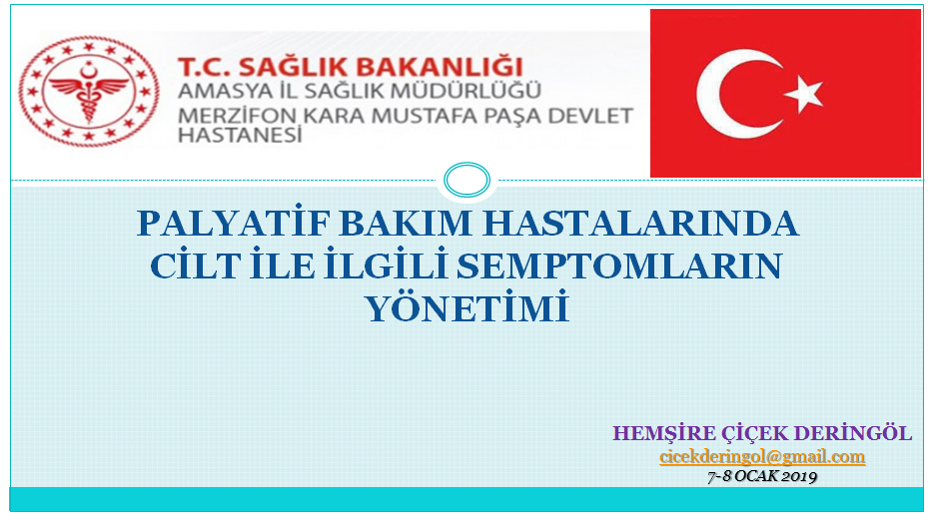
Encounter:
DOBRODOŠLI
Ja sam medicinska sestra Çiçek..
Jako sam sretna što vas opet vidim
(I am very happy to see you again)..
You are a great team.
I am proud to be a colleague with you.
I saw that your approaches are very professional. You look like an adult.
I found your dressing technique successful.
Our wound care application techniques are similar.

Login:
We met you at our Palliative Care Center.
We are the palliative care nurses team.
Palliative care is being treated for nutrition, ache, wound, infection etc.
Symptom management! With Patients and the relatives of the patient..
The palliative patients have lack of movement, they are care patient, you know..
We use Braden Risk Assesment scala like you, and we plan how the care plans will be.
Acute and cronic wound management is very important for us.
In our country, we nurses are good teammates with doctors. We are the most important team in the hospital.
Turkish Ministry of Health give certificate “Stoma and wound care Nursing “ on the wound care course.
There are nurses in wound care and wound care unit of Turkey.

Application:
Our materials are dressing cart, patient file, gloves, crem, sterile gash, wound care products like absorber cover, hydrogels – the dr’s ordered that which one is ordered by the dr, we use it.- wound culture bar if we see any infection symptom.
When preparing the patient, first of all, make analjezik fort his painful procedur by the doctors order.
Effect,ve wound care accelerates healing. Because wound can occur in 24-48 hours.

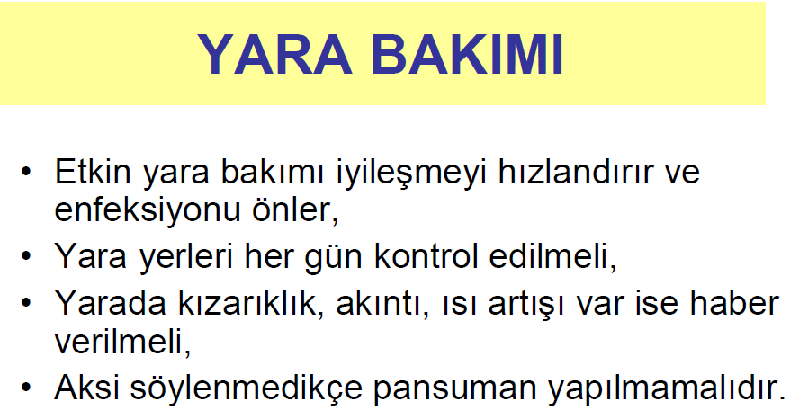
Effective wound care accelerates healing and prevents infections.
Wounds should be checked everyday.
İf the wound has redness, dischange, tempereture increase, the dr should be informed.
Dressing should not be done unless otherwise started. The dr gives directive to dressing.
PANSUMAN ÖNERİLMESİ HALİNDE:
DRESSING SUGGESTION
- YARA TEMİZLEME VE PANSUMANDA DİKKAT EDİLECEKLER:
- WOULD BE CAREFUL IN CLEANING AND DRESSING
- İlk olarak ellerinizi su ve sabunla en az bir dakika yıkayınız.
First, wash your hands with soap and water for at least one minute.

- Tek kullanımlık eldiven giyerek kirli pansuman örtüsünü kaldırınız.
Wearing disposable gloves, remove the dirty dressing cover.

- Eldiveni çıkardıktan sonra tekrar ellerinizi yıkayınız.
Wash your hands again after removing the gloves.

- Tek kullanımlık eldivenden tekrar giyiniz.
Wear again from disposable gloves.

- Önerilen temizleme solüsyonu (baticon) ile steril bir gaz bezi ıslatınız. (Her bir siliş darbesi için yeni bir gaz bezi kullanılmalıdır.)
Wet a sterile gauze pad with the recommended cleaning solution (baticon).
(A new gauze should be used for each wipe stroke.)

- Yarayı yukarıdan aşağıya doğru temizleyiniz. (Yara temiz alandan daha az temiz alana doğru temizlenmelidir.)
Clean the wound from top to bottom.
(The wound should be cleaned from the clean area to a less clean area.)

- İlk önce yara yerinin merkezi, daha sonra yanları yukarıdan aşağıya doğru temizleyiniz.
First clean the center of the wound, then the sides from top to bottom.

- Kapatmanız önerilmişse; Steril bir gazlı bezi tüm kesi alanını kapatacak şekilde örtünüz ve flaster ile yapıştırılarak kapatınız.
If you are suggested to close; Cover a sterile gauze to cover the entire incision area and seal it with a patch.

- Kirli pansuman malzemelerinizi iki kat poşet ile atınız.
Throw your dirty dressing materials into the medical waste bin with two bags.

- Ellerinizi su ve ve sabunla en az bir dakika yıkayınız.
Wash your hands with soap and water for at least one minute

- Kaydet
Record pressure ulcer on track form.

End:
You also saw surgical wounds.
Surgical wound applications are managed with the same discipline.
