Erasmus+ KA2 Project “Innovation in dressing techniques” - Cooperation for innovation and the exchange of good practices
Project Number: 2018-1-HR01-KA202-047488
Monitoring questionnaire

Partner |  | Period from: | 1.10.2018 | To: | 1.1.2019
This questionnaire examines a number of issues relating to the “Innovation in dressing techniques” project.
Please answer referring to the above mentioned period of performance.
Your responses will be treated in strict confidentiality according to the rule on data protection. They will be aggregated and the identity of those completing particular questionnaires will not be divulged.

The questionnaire consists of four parts:
- Implementation: Questions 1 to 9 (appr. 5-8 minutes)
- Outcomes: Questions 10 to 13 (appr. 2-5 minutes)
- Future: Question 14 to 18 (appr. 5-8 minutes)
- Conclusions: Question 19 to 21 (appr. 2-5 minutes)

THANK YOU VERY MUCH FOR YOUR COOPERATION!

A. Implementation
- How much do you feel involved in the following?
(Please tick the appropriate answer, 1= Not involved, …, 4= Very much involved)
 | 1 | 2 | 3 | 4
a. Implementation of project activities | ☐ | ☐ | ☐ | ☐
b. Dissemination of project results | ☐ | ☐ | ☐ | ☐
c. Internal monitoring of the project | ☐ | ☐ | ☐ | ☐

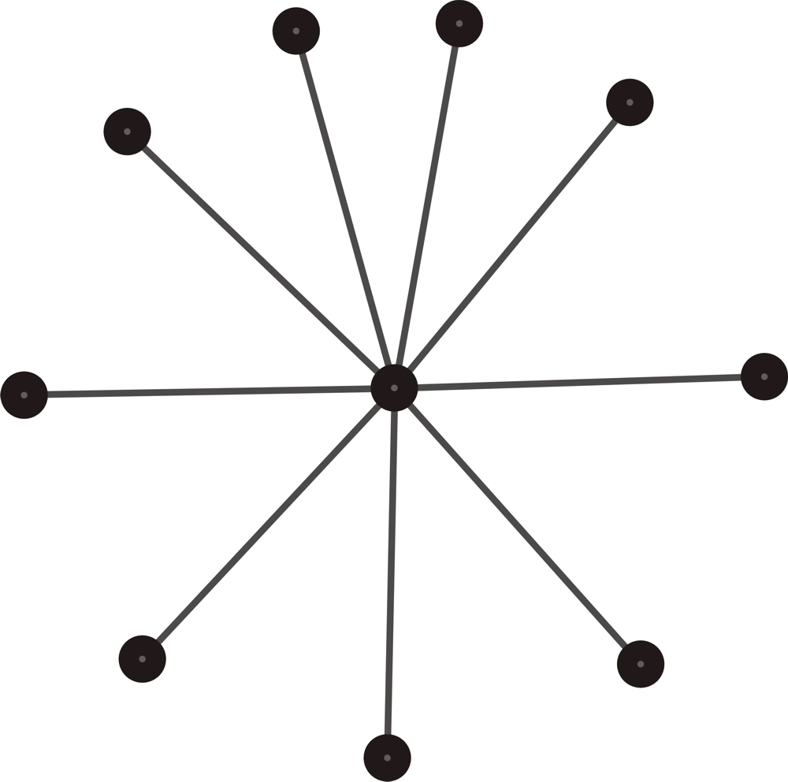
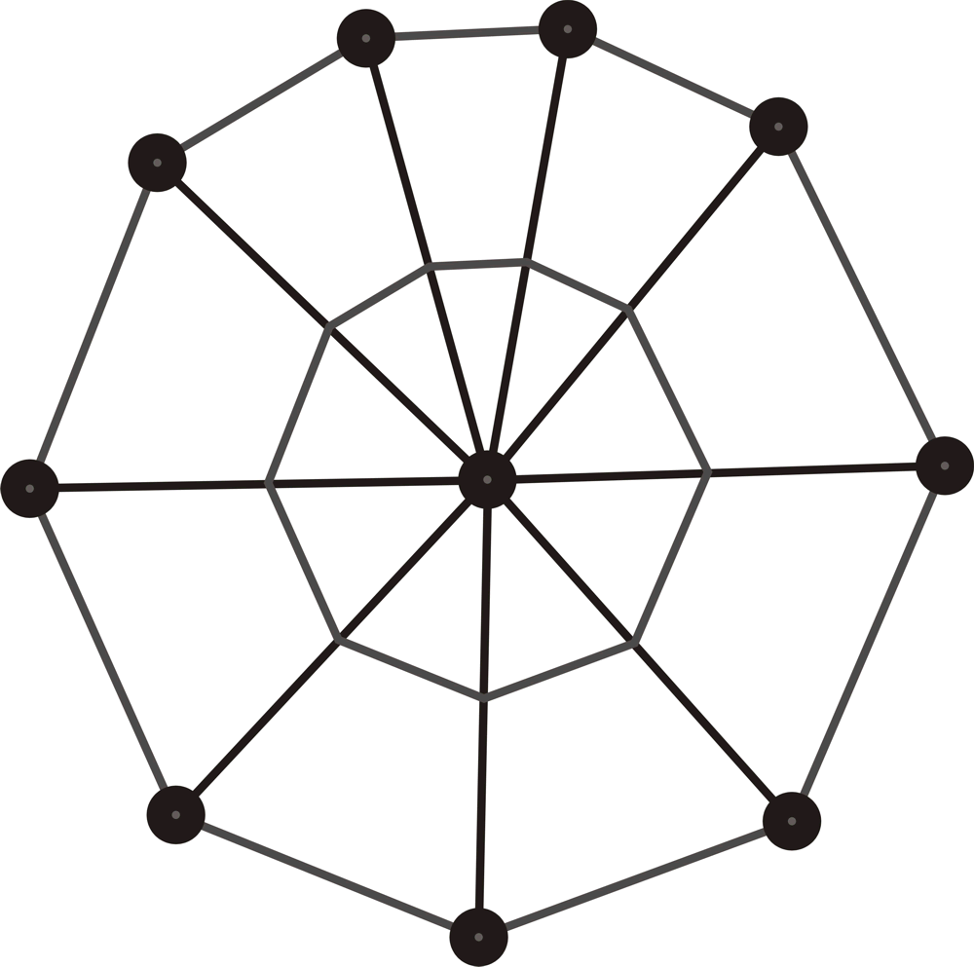
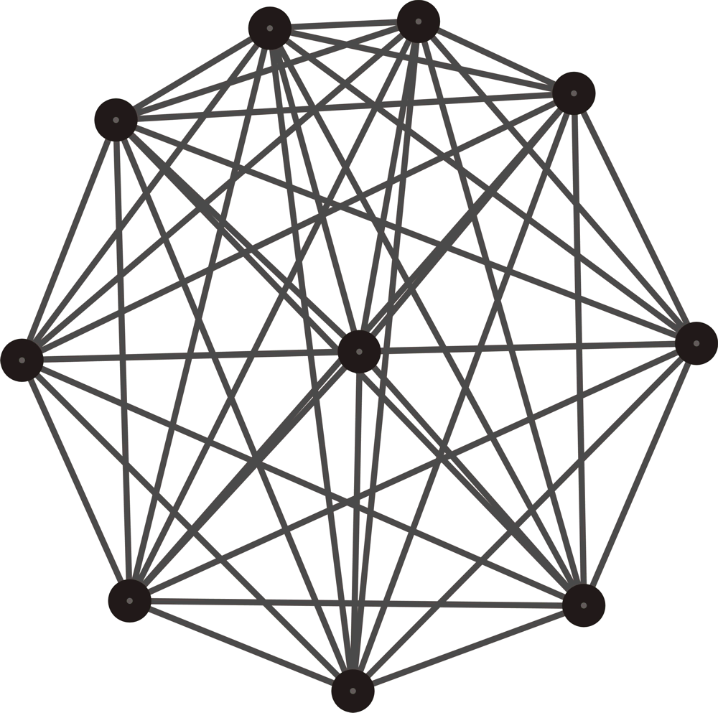
- Which of the pictures below describes best the structures of communication and cooperation in the project?
(Please tick the appropriate answer)
(a) (b) (c)
(a) "Star": Most communication/co-operation between project leader and each of the project partners, very little direct communication/ co-operation between project partners
(b) "Spider’s web": Most communication/ co-operation between project leader and project partners with some project partners also communicating/ co-operating directly
(c) "Fisherman's net": Direct communication/ co-operation between all project partners

- What is the average time necessary to get answers to your questions by other partners?
(Please tick the appropriate answer)
☐ 1 day
☐ 1 - 3 days
☐ about 1 week
☐ over 1 week

- How do you rate your satisfaction as to communication standards and procedures?
(Please tick the appropriate answer, 1= very poor, …, 4=very good)

1 | 2 | 3 | 4
☐ | ☐ | ☐ | ☐

- How do you rate your satisfaction with materials of implementation phase of project - till 1st Transnational Meeting?
(Please tick the appropriate answer, 1= very poor, …, 4=very good)
1 | 2 | 3 | 4
☐ | ☐ | ☐ | ☐

- How do you rate your satisfaction as to functioning of project budget?
(Please tick the appropriate answer, 1= very poor, …, 4=very good)

N/A yet | 1 | 2 | 3 | 4
☐ | ☐ | ☐ | ☐ | ☐

- Overall, how well do project partners work together?
(Please tick the appropriate answer)
☐ Very well Please continue with question 8
☐ Quite well Please continue with question 8
☐ Not well at all

- What are/ were the main problems in co-operating?
(Please put down some key words)
Some changes in the staff on some partners

- Overall, did the project achieve the envisaged outputs so far (for ongoing tasks: intermediate outputs)?
(Please tick the appropriate answer)
☐ Completely
☐ Partially
☐ Not at all

- How would you assess the quality of the outputs achieved?
(Please tick the appropriate answer)
☐ They exceeded our expectations
☐ They met our expectations
☐ They did not meet our expectations. Please explain briefly:

B. Outcomes
- What do you see as the project’s main achievements at this stage?
(Please describe in a few words)

- Considering your organisation, what do you see as the most useful project’s achievements at this stage?
(Please describe in a few words)

- In your view, will the project have any effects on beneficiaries?
(Please tick the appropriate answer)
☐ Yes
☐ No Please continue with question 14
☐ Don’t know Please continue with question 14

- Please describe these effects with a few words:

C. The future
- Will elements of the project, or practices created, be continued in your organisation after the end of the project?
(Please tick the appropriate answer)
☐ Yes
☐ No Please continue with question 16

- Please indicate which elements are being continued and how:

- Do you envisage to keep in contact with project partners after the end of the project?
(Please tick the appropriate answer)
☐ Yes, with all of them
☐ Yes, with some of them
☐ No

- Do you envisage to undertake any joint activities with one or more project partners after the end of the project?
(Please tick the appropriate answer)
☐ Yes
☐ No Please continue with question 19

- Please specify possible types of these joint activities in a few words (partnership in other projects, joint educational/training programmes, mobility exchanges, etc.):

D. Conclusions
- What are in your opinion the two strongest points of the project at this stage?
(Please describe in a few words)
1.

2.

- What are in your opinion the two weakest points of the project at this stage?
(Please describe in a few words)
1.

2.

- All in all, how do you rate the following aspects of the project at this stage?
(Please tick the appropriate answer, 1= poorest, …, 4= best)
 | 1 | 2 | 3 | 4
- Project management | ☐ | ☐ | ☐ | ☐
- Clearness of objectives | ☐ | ☐ | ☐ | ☐
- Clearness of information received | ☐ | ☐ | ☐ | ☐
- Quality of the partnership | ☐ | ☐ | ☐ | ☐
- Clearness of the roles within the partnership | ☐ | ☐ | ☐ | ☐
- Effectiveness of communication among partners | ☐ | ☐ | ☐ | ☐
- Partners’ professional behaviour | ☐ | ☐ | ☐ | ☐
- Level of cooperation among the partners | ☐ | ☐ | ☐ | ☐
- You yourself as a partner | ☐ | ☐ | ☐ | ☐
- Respect of timing and deadlines | ☐ | ☐ | ☐ | ☐
- Your involvement | ☐ | ☐ | ☐ | ☐
- Your commitment | ☐ | ☐ | ☐ | ☐
- Goals achievement | ☐ | ☐ | ☐ | ☐
- Quality of output | ☐ | ☐ | ☐ | ☐
- Usefulness of output for target groups | ☐ | ☐ | ☐ | ☐
- Usefulness of output for your organisation | ☐ | ☐ | ☐ | ☐
- Sustainability of results | ☐ | ☐ | ☐ | ☐
- Quality management | ☐ | ☐ | ☐ | ☐

Finally, please use this space to give any additional comments that you might have.

Thank you very much for taking your time to complete this questionnaire!

The Quality Management team

